Carthage Diagnostic Laboratory-980B Center Street, Carthage, IL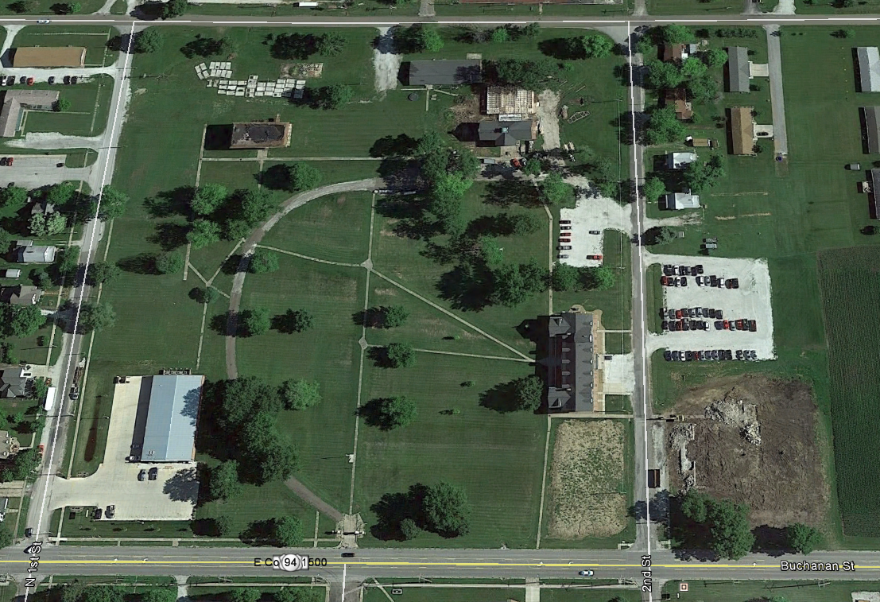
Center Street
N. 2nd Street
CVS Main Office
Parking Lot
CDL (Lab)
Carthage Learning and Development Center (CLDC)
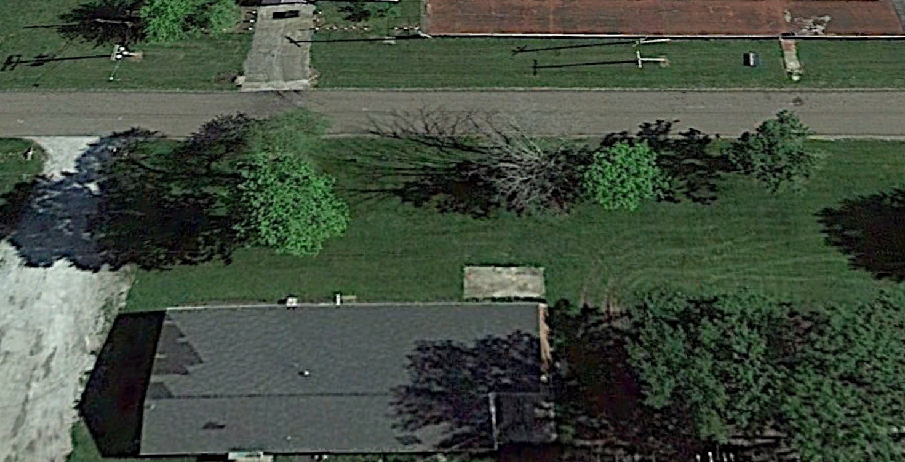
Carthage Diagnostic Laboratory (CDL) 980B Center St.
Sample Submission Window-Ring Door Bell
Parking Lot
Center Street

